**Steam平台优惠信息**

**游戏：Dishonored 2。**链接：<https://store.steampowered.com/app/403640/Dishonored_2/?snr=1_7_7_2300_150_1>  
折扣：-86.0%，价格：¥ 14.0，前价¥ 99.0。

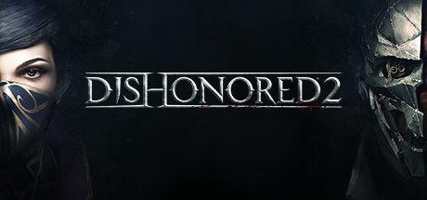

**游戏：Dishonored: Death of the Outsider - Deluxe Bundle。**链接：<https://store.steampowered.com/sub/183038/?snr=1_7_7_2300_150_1>  
折扣：-85.0%，价格：¥ 29.0，前价¥ 199.0。

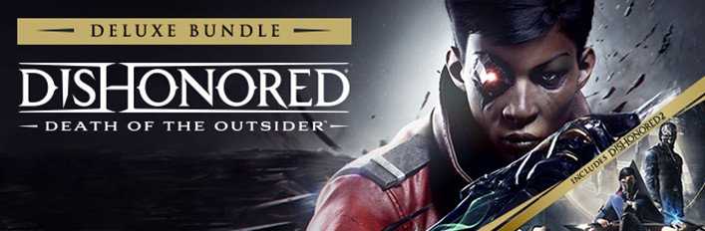

**游戏：Project CARS 2。**链接：<https://store.steampowered.com/app/378860/Project_CARS_2/?snr=1_7_7_2300_150_1>  
折扣：-85.0%，价格：¥ 45.0，前价¥ 305.0。



**游戏：Broforce。**链接：<https://store.steampowered.com/app/274190/Broforce/?snr=1_7_7_2300_150_1>  
折扣：-81.0%，价格：¥ 9.0，前价¥ 48.0。



**游戏：DOOM。**链接：<https://store.steampowered.com/app/379720/DOOM/?snr=1_7_7_2300_150_1>  
折扣：-76.0%，价格：¥ 19.0，前价¥ 79.0。



**游戏：DOOM Eternal。**链接：<https://store.steampowered.com/app/782330/DOOM_Eternal/?snr=1_7_7_2300_150_1>  
折扣：-75.0%，价格：¥ 49.0，前价¥ 199.0。

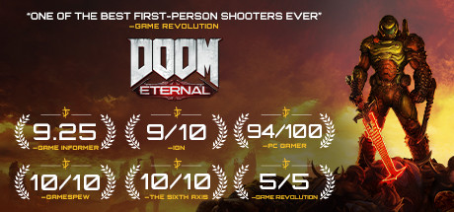

**游戏：Fallout 4: Game of the Year Edition。**链接：<https://store.steampowered.com/sub/199943/?snr=1_7_7_2300_150_1>  
折扣：-75.0%，价格：¥ 32.0，前价¥ 129.0。



**游戏：The Evil Within 2。**链接：<https://store.steampowered.com/app/601430/The_Evil_Within_2/?snr=1_7_7_2300_150_1>  
折扣：-71.0%，价格：¥ 38.0，前价¥ 129.0。



**游戏：Witch It。**链接：<https://store.steampowered.com/app/559650/Witch_It/?snr=1_7_7_2300_150_1>  
折扣：-71.0%，价格：¥ 19.0，前价¥ 65.0。



**游戏：Titanfall® 2。**链接：<https://store.steampowered.com/app/1237970/Titanfall_2/?snr=1_7_7_2300_150_1>  
折扣：-70.0%，价格：¥ 47.0，前价¥ 158.0。



**游戏：Fallout 76。**链接：<https://store.steampowered.com/app/1151340/Fallout_76/?snr=1_7_7_2300_150_1>  
折扣：-67.0%，价格：¥ 42.0，前价¥ 129.0。



**游戏：Fallout 4。**链接：<https://store.steampowered.com/app/377160/Fallout_4/?snr=1_7_7_2300_150_1>  
折扣：-61.0%，价格：¥ 31.0，前价¥ 79.0。



**游戏：Street Fighter V。**链接：<https://store.steampowered.com/app/310950/Street_Fighter_V/?snr=1_7_7_2300_150_1>  
折扣：-61.0%，价格：¥ 44.0，前价¥ 112.0。



**游戏：Football Manager 2021。**链接：<https://store.steampowered.com/app/1263850/Football_Manager_2021/?snr=1_7_7_2300_150_1>  
折扣：-60.0%，价格：¥ 99.0，前价¥ 249.0。



**游戏：The Elder Scrolls V: Skyrim Special Edition。**链接：<https://store.steampowered.com/app/489830/The_Elder_Scrolls_V_Skyrim_Special_Edition/?snr=1_7_7_2300_150_1>  
折扣：-60.0%，价格：¥ 51.0，前价¥ 129.0。



**游戏：Dying Light: Enhanced Edition。**链接：<https://store.steampowered.com/app/239140/Dying_Light_Enhanced_Edition/?snr=1_7_7_2300_150_1>  
折扣：-50.0%，价格：¥ 54.0，前价¥ 109.0。

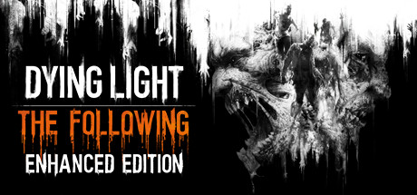

**游戏：Insurgency: Sandstorm。**链接：<https://store.steampowered.com/app/581320/Insurgency_Sandstorm/?snr=1_7_7_2300_150_1>  
折扣：-50.0%，价格：¥ 49.0，前价¥ 98.0。



**游戏：RIDE 4。**链接：<https://store.steampowered.com/app/1259980/RIDE_4/?snr=1_7_7_2300_150_1>  
折扣：-50.0%，价格：¥ 69.0，前价¥ 138.0。



**游戏：Monster Hunter World: Iceborne Master Edition。**链接：<https://store.steampowered.com/bundle/13013/Monster_Hunter_World_Iceborne_Master_Edition/?snr=1_7_7_2300_150_1>  
折扣：-42.0%，价格：¥ 236.0，前价¥ 406.0。

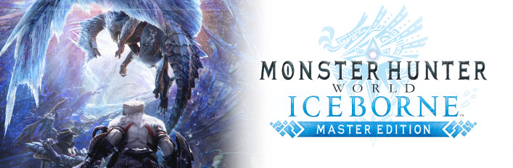

**游戏：Monster Hunter World: Iceborne。**链接：<https://store.steampowered.com/app/1118010/Monster_Hunter_World_Iceborne/?snr=1_7_7_2300_150_1>  
折扣：-38.0%，价格：¥ 168.0，前价¥ 271.0。

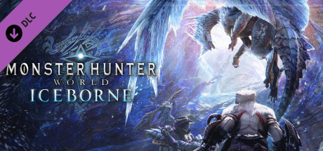

**游戏：Monster Hunter: World。**链接：<https://store.steampowered.com/app/582010/Monster_Hunter_World/?snr=1_7_7_2300_150_1>  
折扣：-34.0%，价格：¥ 133.0，前价¥ 203.0。

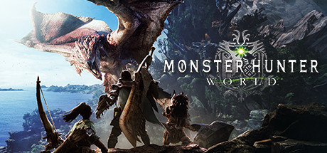

**游戏：Far Away。**链接：<https://store.steampowered.com/app/1250760/Far_Away/?snr=1_7_7_2300_150_1>  
折扣：-21.0%，价格：¥ 33.0，前价¥ 42.0。



**游戏：古剑奇谭网络版 海外版。**链接：<https://store.steampowered.com/app/1541840/_/?snr=1_7_7_2300_150_1>  
折扣：-20.0%，价格：¥ 68.0，前价¥ 85.0。



**游戏：Bless Unleashed - Ultimate Founder's Pack。**链接：<https://store.steampowered.com/app/1663100/Bless_Unleashed__Ultimate_Founders_Pack/?snr=1_7_7_2300_150_1>  
折扣：-10.0%，价格：¥ 189.0，前价¥ 211.0。



**游戏：Car Mechanic Simulator 2021。**链接：<https://store.steampowered.com/app/1190000/Car_Mechanic_Simulator_2021/?snr=1_7_7_2300_150_1>  
折扣：-5.0%，价格：¥ 76.0，前价¥ 80.0。

